Nigeria Gas Production Analysis Report
Date: October 20, 2026
Subject: Analysis of Nigeria's Gas Production Trends and Utilization between 31/1/2021 and 30/06/2025
Data Source: NUPRC Nigeria Gas Production Data [31/1/2021 - 30/06/2025]

Executive Summary
This report provides an analytical overview of Nigeria's natural gas production, utilization, and flaring metrics between January 2021 to June 2025. The analysis highlights key trends in total production volumes, and the ongoing efforts to reduce gas flaring while increasing domestic commercialization and exports.

Total Gas Produced within January 2021 to June 2025
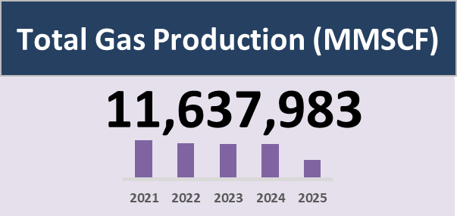
Insight: Total gas production accumulated to 11.6 million MMSCF over the recorded timeframe, displaying a steady annual output through 2024 with a lower total in 2025 reflecting mid-year reporting.

Total Gas Utilized (Export, Field Use, and Domestic sale)
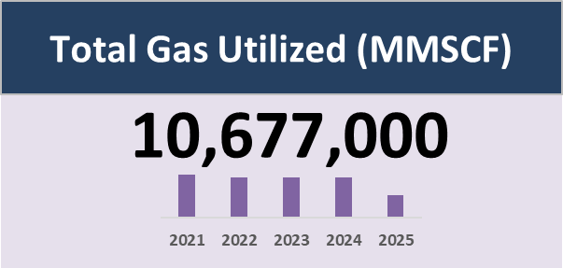
Insight: Out of the total gas produced, 10.67 million MMSCF was successfully utilized, demonstrating high overall commercialization and utilization efficiency across domestic and export markets.

Total Gas Flared
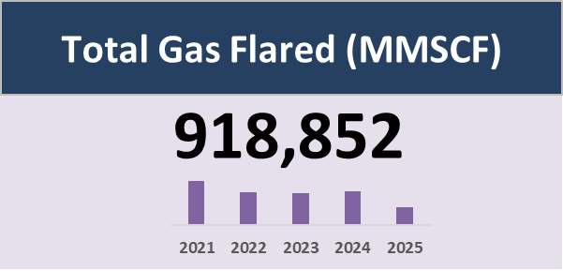
Insight: Flared gas volumes stood at approximately 918,852 MMSCF, representing a relatively small fraction of total production as flaring reduction policies continue to take effect.

Total Gas Shrinkage
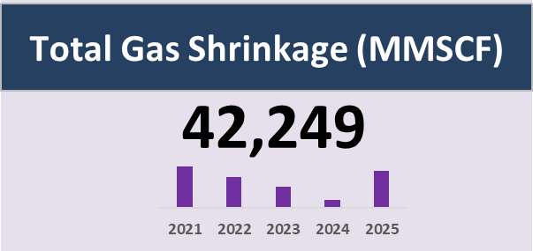
Insight: Gas shrinkage accounted for 42,249 MMSCF, maintaining low levels throughout the period with minor annual fluctuations during gas processing operations.

Overall Production Trends
Over the observed period, Nigeria's total gas production has demonstrated periods of volatility driven by infrastructural challenges and global market demands.
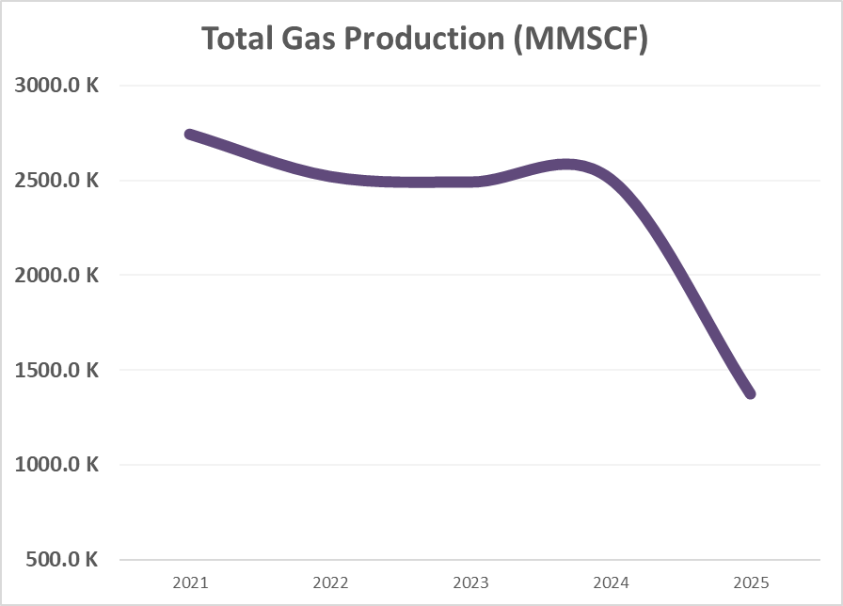
Insight: Annual production remained relatively stable around 2.5 million MMSCF between 2021 and 2024 before trailing off due to the partial-year timeframe for 2025.

Percentage Contribution of Associated and Non-associated Gas to Total Gas Production
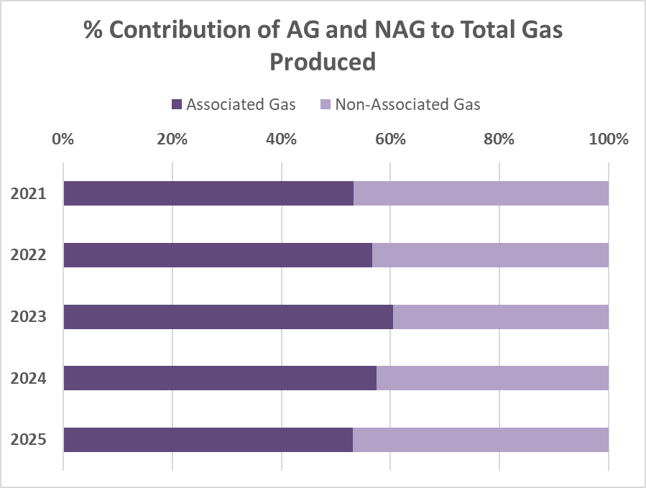
Insight: Associated Gas (AG) consistently accounted for the slight majority (~53–60%) of total production compared to Non-Associated Gas (NAG), showing a balanced operational mix.
Gas Utilization vs. Flaring
A primary focus of national energy policy is the reduction of gas flaring and the enhancement of gas commercialization (both domestic use and Liquefied Natural Gas exports).
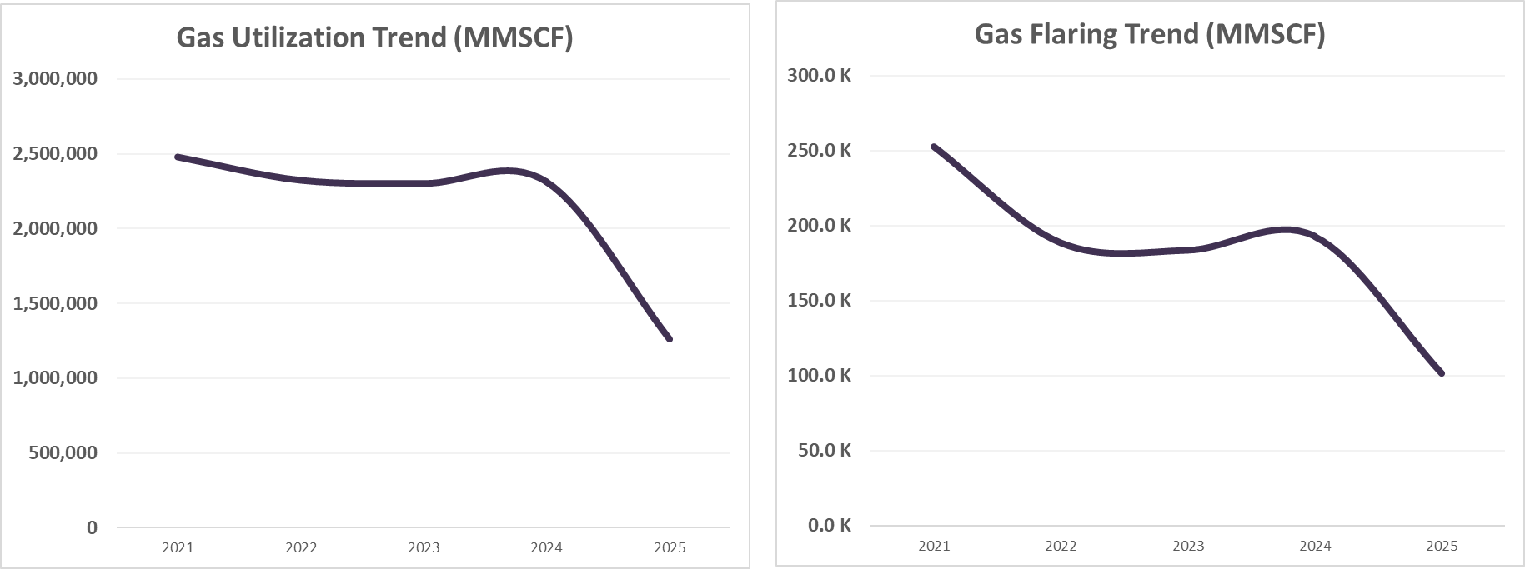
Insight: Both utilization and flaring curves follow similar overarching trends, with gas utilization consistently far outstripping flaring volumes across all years.

Percentage Gas Utilization in each Category (Exported Sale, Field Usage, Domestic Sale)

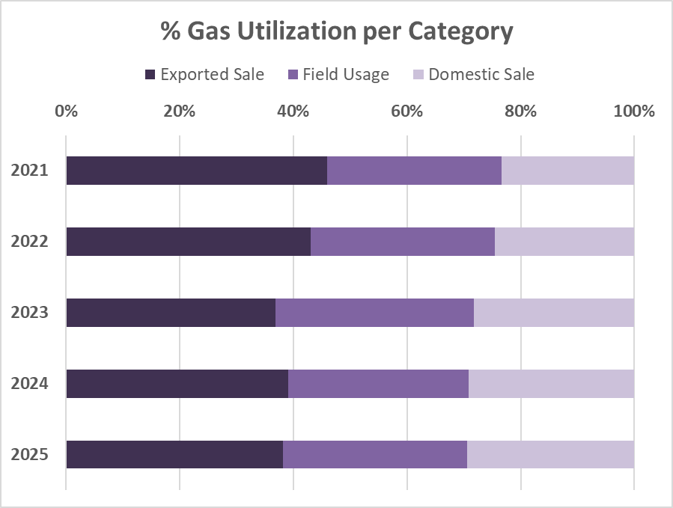
Insight: Export sales represent the largest share of gas utilization (~38–46%), followed by field usage (~30–35%) and domestic sales (~22–27%).

Domestic vs Export Sales

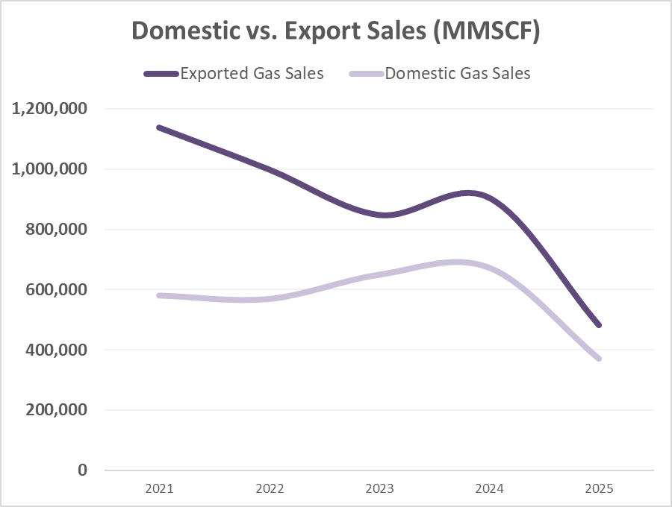
Insight: Export sales consistently exceeded domestic sales across the entire period, though domestic sales experienced gradual upward growth through 2024 relative to export levels.

Conclusion
The analysis indicates robust utilization of produced natural gas in Nigeria, with the vast majority directed toward export, field operations, and domestic markets. Efforts to minimize flaring and shrinkage continue to yield positive structural trends, though export demand remains the predominant revenue driver compared to expanding domestic supply channels.

